**ReactJS-HOL- Exercise 2**

**1. React Components**

React components are the core building blocks of a React application.  
They are independent, reusable pieces of UI that return JSX (a combination of HTML and JavaScript).  
Components help in breaking the UI into smaller, manageable parts.

**2. Difference Between Components and JavaScript Functions**

* JavaScript functions perform logic and return values like numbers, strings, or objects.
* React components return JSX, which defines the structure and content displayed on the UI.
* React components can have internal state, lifecycle, and UI behavior, whereas standard JavaScript functions cannot.

**3. Types of Components**

There are two main types of components in React:

1. Class Components – Based on ES6 classes, can manage state and lifecycle methods.
2. Function Components – Based on JavaScript functions; with React Hooks, they can also manage state and side effects.

**4. Class Component**

A class component is a component that extends React.Component.  
It must include a render() method that returns JSX.  
Class components have access to state and lifecycle methods like componentDidMount(), componentDidUpdate(), etc.

**5. Function Component**

A function component is a simple JavaScript function that returns JSX.  
Originally used for presentational purposes only, but now with Hooks, function components can handle state, effects, and context.  
They are more concise and widely used in modern React applications.

**6. Component Constructor**

The constructor is a special method used only in class components.  
It is called once when the component is created.  
It's mainly used to:

* Initialize state
* Bind event handlers to this

The constructor must call super(props) before accessing this.

**7. render() Function**

The render() function is required in class components.  
It returns the JSX that represents the component’s UI.  
It gets called whenever the component’s state or props change, triggering a re-render of the UI.

**HANDSON:**

1. Create a React project named “StudentApp” type the following command in terminal of Visual studio:



1. Create a new folder under Src folder with the name “Components”. Add a new file named “Home.js”

* Type the following code in Home.js:

import React from 'react';

function Home() {

  return (

    <div>

      <h2>Welcome to the Home page of Student Management Portal</h2>

    </div>

  );

}

export default Home;

1. Under Src folder add another file named “About.js”
2. Repeat the same steps for Creating “About” and “Contact” component by adding a new file as ”About.js”, “Contact.js” under “Src” folder and edit the code as mentioned for “Home” Component.
3. Edit the App.js to invoke the Home, About and Contact component as follows:

**Code for App.js:**

import React from 'react';

import './App.css';

import Home from './Components/Home';

import About from './Components/About';

import Contact from './Components/Contact';

function App() {

  return (

    <div className="App">

      <Home />

      <About />

      <Contact />

    </div>

  );

}

export default App;

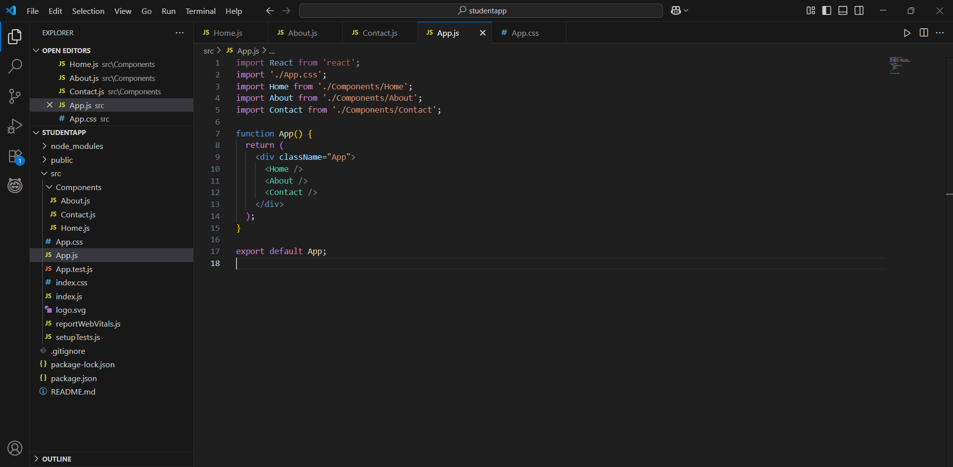

1. In command Prompt, navigate into StudentApp and execute the code by typing the following command:



1. Open browser and type “localhost:3000” in the address bar:

* **OUTPUT:**

